JavaScript Regular Expressions

A regular expression is a sequence of characters that forms a search pattern.

The search pattern can be used for text search and text replace operations.

## **What Is a Regular Expression?**

A regular expression is a sequence of characters that forms a **search pattern**.

When you search for data in a text, you can use this search pattern to describe what you are searching for.

A regular expression can be a single character, or a more complicated pattern.

Regular expressions can be used to perform all types of **text search** and **text replace** operations.

## **Syntax**

**/pattern/modifiers;**

**Modifiers**

**Modifiers are used to perform case-insensitive and global searches:**

**Modifier Description**

**g Perform a global match (find all matches rather than stopping   
 after the first match)**

**i Perform case-insensitive matching**

**m Perform multiline matching**

## **Using String Methods**

In JavaScript, regular expressions are often used with the two **string methods**: search() and replace().

The search() method uses an expression to search for a match, and returns the position of the match.

The replace() method returns a modified string where the pattern is replaced.

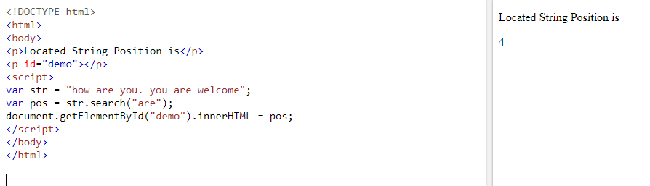

Using String search() With a Regular Expression

Use a regular expression to do a case-insensitive search for "GRAPHIC" in a string:

var str = "Visit GRAPHIC Era University";

var n = str.search(/Graphic/i);

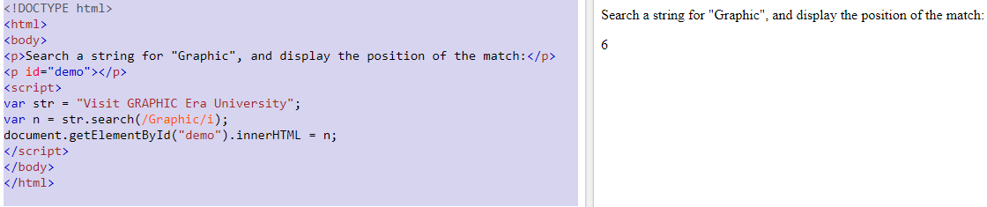

Replacing String Content

The replace() method replaces a specified value with another value in a string:

var str="Please visit Java Programming!"

var n=str.replace("java", "WebDesign");

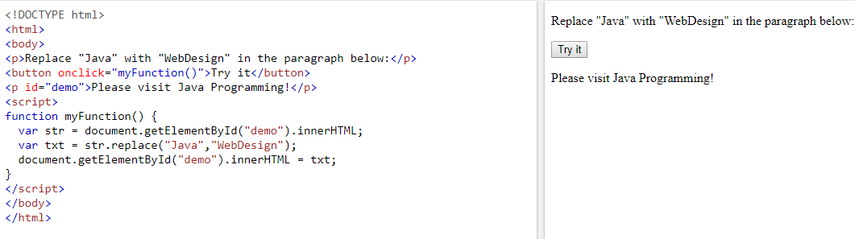

By default, the replace() method replaces **only the first** match:

To replace case insensitive, use a **regular expression** with an /i flag (insensitive):

str = "Please visit Microsoft!";  
var n = str.replace(/MICROSOFT/i, "WIPRO");

To replace all matches, use a **regular expression** with a /g flag (global match):

### Example

str = "Please visit Microsoft and Microsoft!";  
var n = str.replace(/Microsoft/g, "WIPRO");

To replace all matches, with a /g flag (global match)and an /i flag (insensitive):

var n = str.replace(/Microsoft/gi, "WIPRO");

<!DOCTYPE html>

<html>

<body>

<p> New String is</p>

<p id="demo"></p>

<script>

str="web programming web developer web design"

var nstr = str.match(/web/gi);

document.getElementById("demo").innerHTML = nstr;

</script>

</body>

</html>

OutPut

New String is

web,web,web

## 

## **RegExp Object Methods**

## **1 exec()**

**2 test()  
3 toString()**

**JavaScript - RegExp exec() Method**

## **Description**

The **exec() Method**in JavaScript is used to test for match in a string. If there is a match this method returns the first match else it returns NULL.

**<!DOCTYPE html>**

**<html>**

**<body>**

**<p> New String is</p>**

**<p id="demo"></p>**

**<script>**

**str="web programming web developer web design"**

**var nstr = /web/.exec(str);**

**document.getElementById("demo").innerHTML = nstr;**

**</script>**

**</body>**

**</html>**

**Output**

New String is

web

**<!DOCTYPE html>**

**<html>**

**<body>**

**<p> New String is</p>**

**<p id="demo"></p>**

**<script>**

**str="web programming web developer web design"**

**var reg = new RegExp("web");**

**var nstr = reg.exec(str);**

**document.getElementById("demo").innerHTML = nstr;**

**</script>**

**</body>**

**</html>**

# JavaScript RegExp test() method

## **Definition and Usage**

**The test() method tests for a match in a string.**

**If it finds a match, it returns true, otherwise it returns false.**

**!DOCTYPE html>**

**<html>**

**<body>**

**<p> New String is</p>**

**<p id="demo"></p>**

**<script>**

**str="web programming web developer web design"**

**var nstr = /web/.test(str);**

**document.getElementById("demo").innerHTML = nstr;**

**</script>**

**</body>**

**</html>**

**Output**

**New String is**

**true**

**Exmple2**

**<!DOCTYPE html>**

**<html>**

**<body>**

**<p> New String is</p>**

**<p id="demo"></p>**

**<script>**

**let str="web programming web developer web design"**

**let pattern=/web/**

**var nstr = pattern.test(str);**

**document.getElementById("demo").innerHTML = nstr;**

**</script>**

**</body>**

**</html>**

# JavaScript RegExp toString() method

## **Definition and Usage**

The toString() method returns the string value of the regular expression.

**<!DOCTYPE html>**

**<html>**

**<body>**

**<p> New String is</p>**

**<p id="demo"></p>**

**<script>**

**str="web programming web developer web design"**

**var reg = new RegExp("web");**

**var nstr = reg.toString(str);**

**document.getElementById("demo").innerHTML = nstr;**

**</script>**

**</body>**

**</html>**

**Output**

**New String is**

**/web/**

**var reg = new RegExp("web","gi");**

**var nstr = reg.toString(str);**

**Output**

**New String is**

**/web/gi**

**Brackets [ ]**

**Brackets are used to find a range of characters:**

**Expression Description**

**[abc] Find any character between the  
 brackets**

**[^abc] Find any character NOT between the  
 brackets**

**[0-9] Find any character between the   
 brackets (any digit)**

**[^0-9] Find any character NOT between the   
 brackets (any non-digit)**

**(x|y) Find any of the alternatives specified**

**[0-9] It matches any decimal digit from 0 through 9.**

**[a-z] It matches any character from lowercase a through lowercase z.**

**[A-Z] It matches any character from uppercase A through uppercase Z.**

**[a-Z] It matches any character from lowercase a through uppercase**

**<!DOCTYPE html>**

**<html>**

**<body>**

**<p> New String is</p>**

**<p id="demo"></p>**

**<script>**

**str="web programming web developer meb design jeb Design"**

**var nstr = str.match(/[wmj]eb/g);**

**document.getElementById("demo").innerHTML = nstr;**

**</script>**

**</body>**

**</html>**

**Output**

**New String is**

**web,web,meb,jeb**

**To ignore case**

**ar nstr = str.match(/[wmjWMJ]eb/g);**

**var nstr = str.match(/[wmJ]eb/gi);**

**Example**

**var nstr = str.match(/[a-z]eb/gi);**

**<!DOCTYPE html>**

**<html>**

**<body>**

**<p> New String is</p>**

**<p id="demo"></p>**

**<script>**

**str="sengupta dasgupta vimalgupta are web developers"**

**var nstr = str.match(/(sengupta|dasgupta)/g);**

**document.getElementById("demo").innerHTML = nstr;**

**</script>**

**</body>**

**</html>**

**output**

**New String is**

**sengupta,dasgupta**

**Quantifiers**

**Quantifier Description**

**n+ Matches any string that contains at least one n**

**n* Matches any string that contains zero or more  
 occurrences of n**

**n? Matches any string that contains zero or one   
 occurrences of n**

**n{X} Matches any string that contains a   
 sequence of X n's**

**n{X,Y} Matches any string that contains a   
 sequence of X to Y n's**

**n{X,} Matches any string that contains a   
 sequence of at least X n's**

**n$ Matches any string with n at the end of it**

**^n Matches any string with n at the beginning of it**

**?=n Matches any string that is followed by a   
 specific string n**

**?!n Matches any string that is not followed by a   
 specific string n**

**n+ Matches any string that contains at least one n**

**<!DOCTYPE html>**

**<html>**

**<body>**

**<p> New String is</p>**

**<p id="demo"></p>**

**<script>**

**str="aggarwal agarwal agggarwal aarwal are web developer"**

**var nstr = str.match(/g+/g);**

**document.getElementById("demo").innerHTML = nstr;**

**</script>**

**</body>**

**</html>**

**Output**

**New String is**

**gg,g,ggg**

**<!DOCTYPE html>**

**<html>**

**<body>**

**<p> New String is</p>**

**<p id="demo"></p>**

**<script>**

**str="aggarwal agarwal Agggarwal aarwal are web developer"**

**var nstr = str.match(/[aA]g+arwal/g);**

**document.getElementById("demo").innerHTML = nstr;**

**</script>**

**</body>**

**</html>**

**Output**

**New String is**

**aggarwal,agarwal,Agggarwal**

**n* Matches any string that contains zero or   
 more occurrences of n**

**<script>**

**str="aggarwal agarwal Agggarwal aarwal are web developer"**

**var nstr = str.match(/[aA]g*arwal/g);**

**document.getElementById("demo").innerHTML = nstr;**

**</script>**

**Output**

**New String is**

**aggarwal,agarwal,Agggarwal,aarwal**

**n? Matches any string that contains zero or   
 one occurrences of n**

**<script>**

**str="aggarwal agarwal Agggarwal aarwal are web developer"**

**var nstr = str.match(/[aA]g?arwal/g);**

**document.getElementById("demo").innerHTML = nstr;**

**</script>**

**Output**

**New String is**

**agarwal,aarwal**

**n{X} Matches any string that contains a   
 sequence of X n's**

**<script>**

**str="5009 45009 234 56789 12"**

**var nstr = str.match(/\d{4}/g);**

**document.getElementById("demo").innerHTML = nstr;**

**</script>**

**Output**

**New String is**

**5009,4500,5678**

**n{X,Y} Matches any string that contains a   
 sequence of X to Y n's**

**Searching for digit 3 to 4 range**

**<script>**

**str="5009 45009 234 56789 12"**

**var nstr = str.match(/\d{3,4}/g);**

**document.getElementById("demo").innerHTML = nstr;**

**</script>**

**Output**

**New String is**

**5009,4500,234,5678**

**Searching for word 4 to 5 range**

**<script>**

**str="hello welcome to java script program"**

**var nstr = str.match(/\w{4,5}/g);**

**document.getElementById("demo").innerHTML = nstr;**

**</script>**

**Output**

**New String is**

**hello,welco,java,scrip,progr**

**n{X,} Matches any string that contains a   
 sequence of at least X n's**

**<script>**

**str="hello welcome to java script program"**

**var nstr = str.match(/\w{4,}/g);**

**document.getElementById("demo").innerHTML = nstr;**

**</script>**

**Output**

New String is

hello,welcome,java,script,program

**n$ Matches any string with n at the end of it**

**<!DOCTYPE html>**

**<html>**

**<body>**

**<p> New String is</p>**

**<p id="demo"></p>**

**<script>**

**str="sandeep mandeep varun vijay rahul amandeep rajdeep"**

**let astr=str.split(" ")**

**result=""**

**for(i=0;i<astr.length;i++)**

**{**

**nstr = astr[i].match(/[a-z]*deep$/);**

**if(nstr!=null)**

**result=result+nstr+" "**

**}**

**document.getElementById("demo").innerHTML = result**

**</script>**

**</body>**

**</html>**

**Output**

**New String is**

**sandeep mandeep amandeep rajdeep**

**^n Matches any string with n at the beginning of it**

**<!DOCTYPE html>**

**<html>**

**<body>**

**<p> New String is</p>**

**<p id="demo"></p>**

**<script>**

**str="sandeep sanjay varun vijay amarsan saneev sanjiv"**

**let astr=str.split(" ")**

**result=""**

**for(i=0;i<astr.length;i++)**

**{**

**nstr = astr[i].match(/^san[a-z]*/);**

**if(nstr!=null)**

**result=result+nstr+" "**

**}**

**document.getElementById("demo").innerHTML = result**

**</script>**

**</body>**

**</html>**

Output

**New String is**

**sandeep sanjay saneev sanjiv**